The Cleveland Open Source Modular Implant Innovators Community (COSMIIC)

This talk will introduce the Cleveland Open Source Modular Implant Innovators Community (COSMIIC) – see cosmiic.org. The overall goal of COSMIIC is to establish an open source, modular network of active implantable devices for use in pre-clinical and early feasibility human research, and to provide ongoing support for this technology through a vibrant, sustainable community of users. The concept is based on our established platform ecosystem, the Networked Neuroprosthesis (NNP), which provides a solid technological platform with an established regulatory status for human use. The COSMIIC concept is being established through major funding from the National Institutes of Health (NIH) Stimulating Peripheral Activity to Relieve Conditions (SPARC) Program. The project includes a broad investigative team in Cleveland at CWRU, MHS, VA Northeast Ohio Healthcare System, and the Cleveland Clinic Lerner College of Medicine; as well as investigators at the University of Michigan and the University of California, Los Angeles (UCLA).
The goal of the COSMIIC project is to fundamentally change the bioelectronic research landscape by developing the most advanced assemblage of modular interoperable implantable components yet conceived, and then license this technology to the world, for free, without any limits imposed on its future use, modification, dissemination, or commercialization. There are two overall aims of the COSMIIC Project:
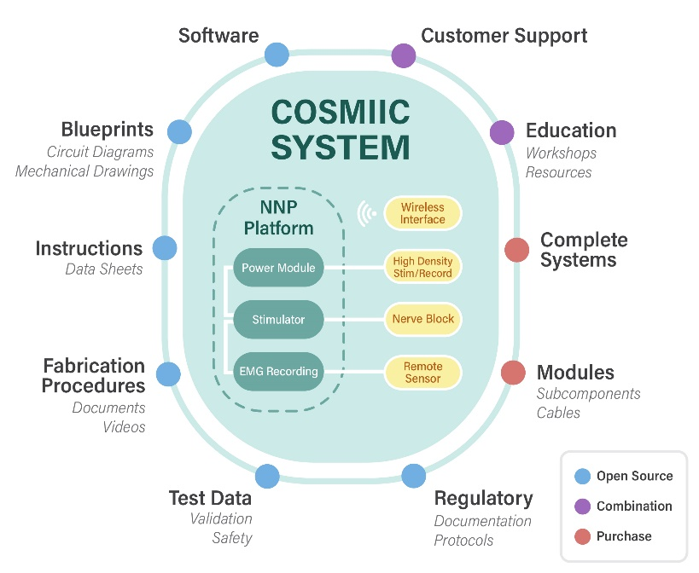
Aim #1. Dissemination. We will establish the COSMIIC community with full open-source access to an established modular implantable device for use in the peripheral and central nervous system. Access will be given for all circuit designs and layouts; mechanical drawings for all enclosures, connectors and cabling; the annotated code for all operating software, firmware, and bootloader; written instructions and videos of fabrication techniques; and all regulatory documents and test data, including our approved IDE document. We also propose an extensive educational component to increase expertise in the design and use of active implantable devices for bioelectronic, neuromodulation, and neuroprosthetic applications.
Aim #2. Sustainability. We will develop a sustainable open source model through the development of technology that attracts a broad investigative team to establish a critical mass of COSMIIC users. We will provide ongoing support of the technology and partner with commercial manufacturers to create a sustainable business plan so that the COSMIIC community remains independently vibrant and active beyond three years.

